MISSION:
To help people, to help students find creative ways to deal with life issues, work hard and believe in themselves through the arts and athletics, helping them to excel in school and in life.
- How? Mental and physical stimulation, utilizing their own creativity via the arts and physical fitness.
- Why? Today’s youth need direction, real leadership, instruction and a creative outlet for self expression
- Subjects: Attitude, Imagination, Work Ethic, Respect, Peer Pressure, Labeling , Bullying
- U-KAN!: U-can do anything if U K-now what you want, make A-plan to get it and N-ever give up
U-KAN!
U-KAN is the main message of the Choices Program. No on is perfect, which is why we spell Kan with a “K.” Everyone has issues and obstacles they must overcome to be successful. No matter your mistakes, your circumstances, your imperfections, your obstacles…with the right attitude and work ethic, U-KAN!
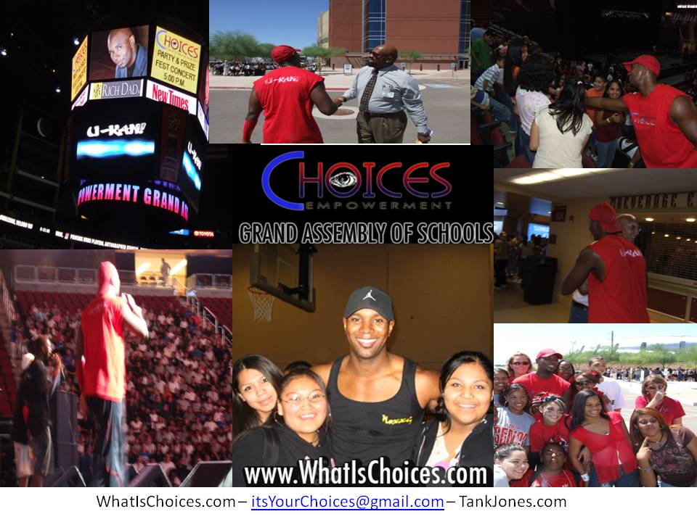
- Description: Choices is a non profit year-round motivational program whose message is delivered via assembly. The wording and images are tailored for elementary, middle and high school students.
- Format: Musical Performances, School Pride and Games, Multi-media Presentation, Theatrical Performance that includes the students, Sound, Lights, Entertaining, yet inspirational and unique learning experience that “sticks”
- Assembly Time: 35-50 minutes, depending on student participation
- Follow Up: Activity Book Groups online and after school (if wanted by the school). Additional assemblies covering different topics, year after year. Choices Empowerment Activity Groups, Community Events, Games, Awards, Scholarships
- Investment: $2000* (*grants and donations available to underfunded schools)
OUR HISTORY
- Started in 2003

- Spoke at over 100 schools across Southwest
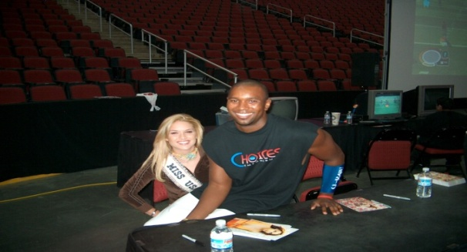
- 40 Schools, over 5,000 students @ Grand Assembly of Schools, Jobing.com Arena

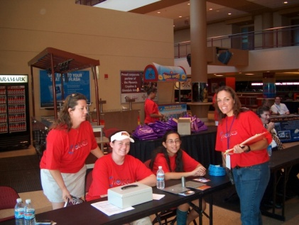
- Multiple Community Events

- Endorsed by New Mexico Dept. of Education

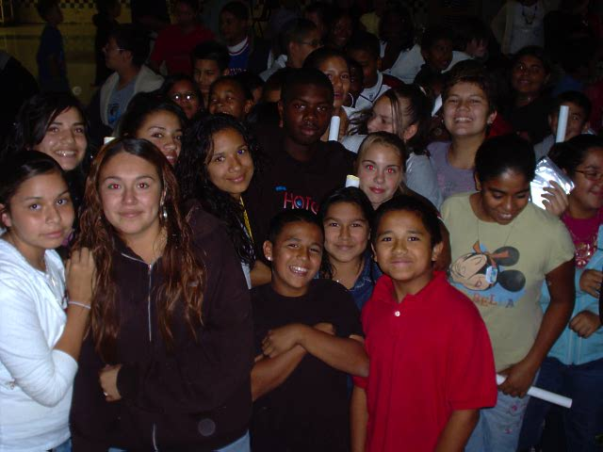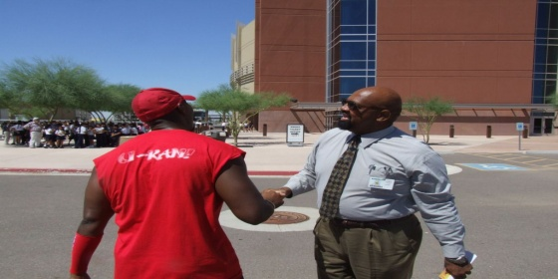
WHY CHOICES
The world today is a highly connected, microwave and reality tv society. Fame, by any means necessary has supplanted education as the ticket to a better life in the mind of the American student. Recent statistics show that over 50% of America’s student body wants to be or believes they will be an actor, an artist or a professional athlete of some kind. President Obama continues to tour and speak about the state of education in America and how the U.S. has fallen behind in math, reading, science and innovation. Today’s youth need direction, real leadership, instruction and a creative outlet for self expression.
The Choices Education Empowerment Program was created to help people, to help students find creative ways to deal with life issues, find value in working hard and believing in themselves to excel in school and in life. The program utilizes the arts and athletics to accomplish this mission.
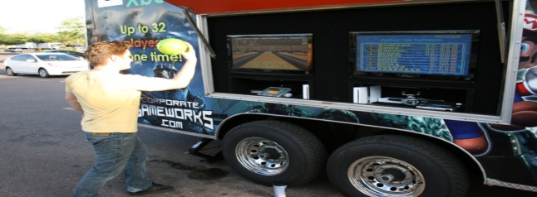
Smart phones, Ipods, YouTube and Facebook are large parts of modern day life, and that is especially true for today’s student. When teachers are vying for the attention of today’s student against these “distractions,” oftentimes they lose the battle. Choices has learned to use these “distractions” of modern society youth as incentives to motivate them. The Choices message is delivered by people that kids want to listen to and emulate. It is delivered via a medium they want to be a part of – drama, music, sports, and interactive activities.
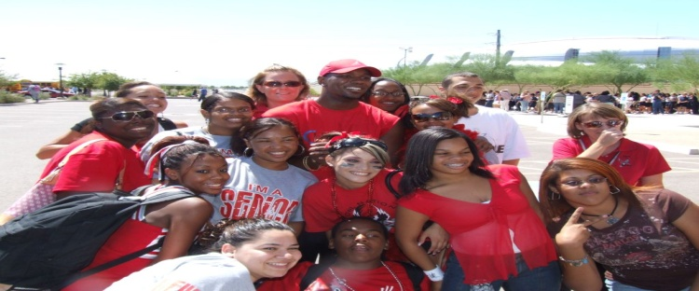
The Choices Program delivers its messages in four different, but connected mediums:
- The School Assembly
- The After School Activity Book Group
- Community Events
- The Choices Empowerment Centers
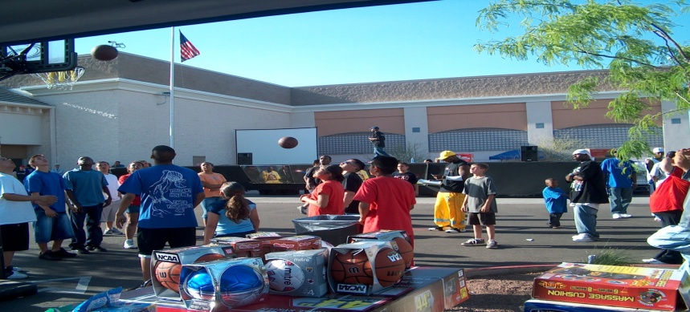
To further root the message of the assembly into the student body, there are activity books that re-enforce the message. Groups of 10-30 students meet once a week to complete fun but deliberate activities and share them with others.
Community Events give Choices the opportunity to speak with the parents and the community at large about the message to the children. These events feature fun games, inflatables, prize raffles, performances and other fun surprises. The Empowerment Centers are a future project to come.
QUOTABLES
“One of the best programs to present at this school.”
Kristy Kinsel, Teacher at Northwest High School
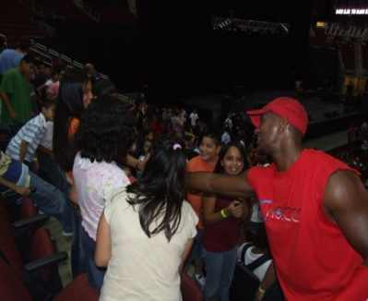
“It was good. Excellent! Schools are in need of more programs like this.”
Paul T Davis, Zuni Police
“I think it’s the most dynamic, motivational message that I’ve seen presented to young people.”
Curtis Rosemond, Las Cruces Wal Mart Store Manager
“Nexxis (Tank), you were so great here at my school in Questa! You inspired me so much!”
Lynda A., Questa High School Student
“Great message and you grabbed the students attention from the start.!”
Brian Collier, Counselor at Atkinson Middle School
“Tank spent time with the students afterwards and this greatly impacted them.”
Wilma Smith, Principal at Mariposa Elementary
“You are doing the youth of our society a great deed, and through your work, you will be rewarded.” Anna Miller, Teacher at Mariposa Elementary
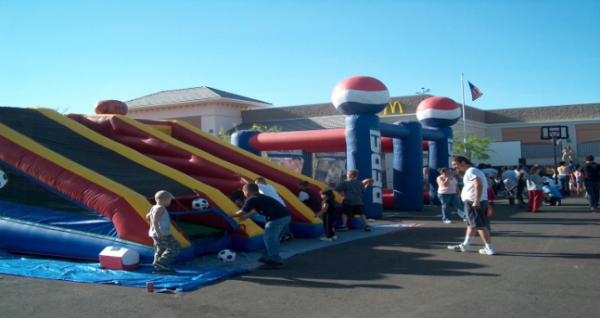
“I work with Character Education and this was great!”
Cindy Hilts, Administrator of Zuni Public Schools
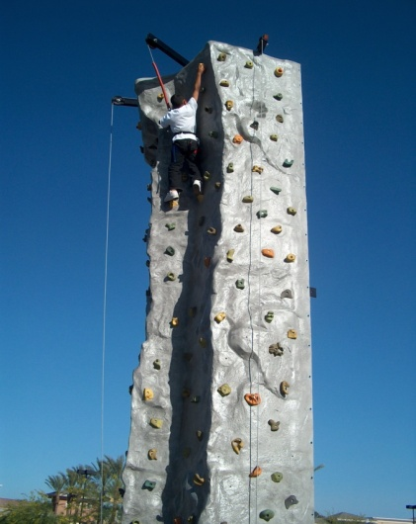

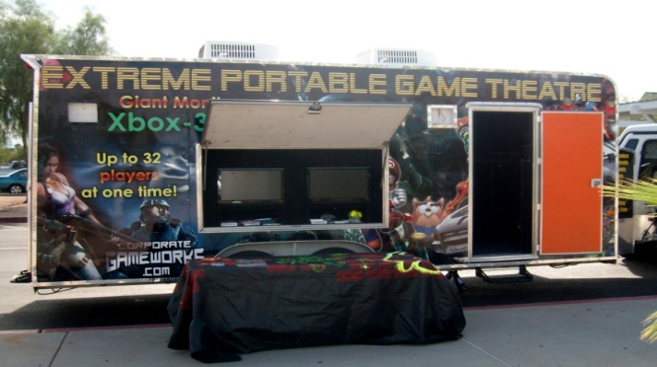
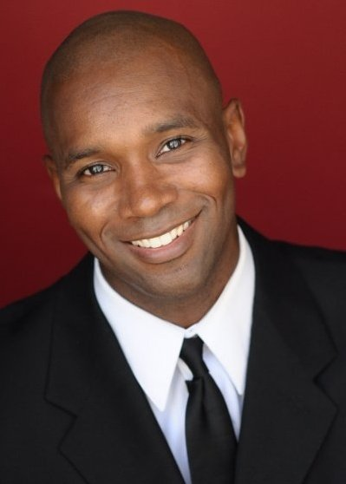
Featured speaker
Tank Jones
The name Nexxis (Tank's stage name) means “fantasy made into reality” and this is exactly what is happening with the actor, performer and Choices founder, Tank Jones. As an actor, Tank Jones has shared the big screen with the likes of George Clooney, Al Pacino, Richard Roundtree, and Mark Wahlberg. His film roles include two Warner Bros. pictures, Three Kings and Any Given Sunday. Tank was also cast as a lead or supporting actor in several independent features that have been released worldwide as well, including Alien Invasion, The Controller, and Wild Seven. Most recently, Tank had the good fortune of starring in two national commercials, including an All Detergent commercial with his oldest daughter. Guest roles on popular tv shows, CSI: Miami, Rules of Engagement and an NBC pilot made opportunities for Tank, the actor more abundant as well. (www.TankJones.com)
As a hip hop artist, Tank has released half a dozen albums and received multiple endorsements from Pepsi, Budweiser and Wal Mart. In addition to those feats, Tank has also performed for the Miss USA Pageant and co hosted the pre-show.
Inspired by an event that took place at his high school, Tank created the Choices Education Program. In the program, Tank uses his skills as an actor and artist in order to help people remain hopeful and optimistic that all things are possible for their futures. When Tank isn’t acting in a film project he speaks to elementary, middle school and high school students, encouraging them to go after their dreams.
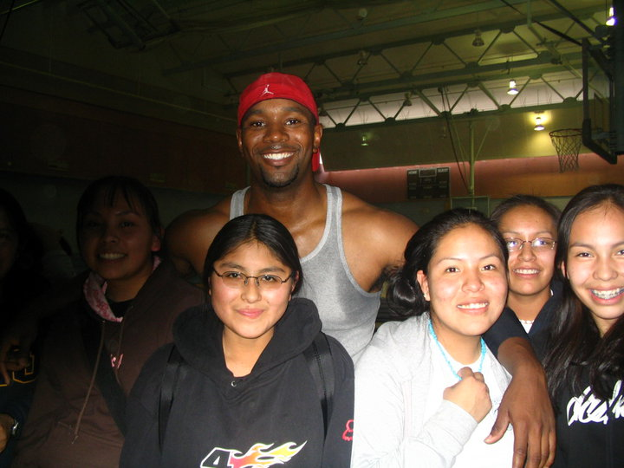
Currently, Tank is speaking all over the Southwest on behalf of the Choices program. Through the program, academic scholarships are offered as well as apprenticeships on feature films and commercials.
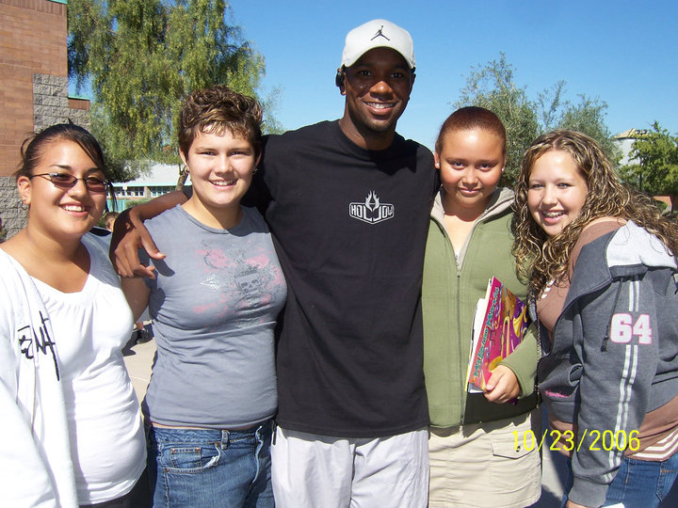

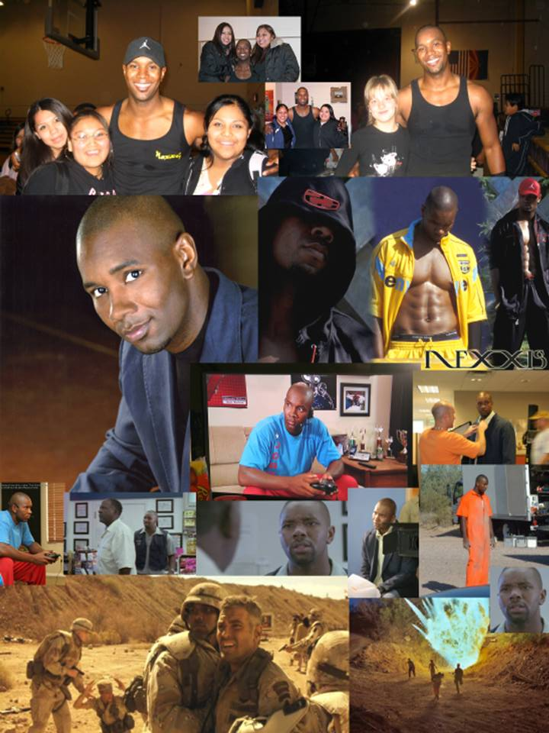
“Students really need good role models who are gifted and interested in what they are into. I know you have no idea of the background history of some of the students you talk to and make feel special. There was one student you took a picture with who tried to commit suicide just after school started this year. I saw the student's face just light up when she stood next to you. Thank you for giving her something special to treasure. If you ever wonder if you are making a difference, I would say that you are.” Anonymous
AGREEMENT
This is an agreement with the Choices Education Program and _____________________ regarding upcoming school assembly titled “Choices” with the Choices Education Empowerment Program. The performance is to take place on ____________________.
Compensation:
The cost of the assembly on ____________________ is $2000. School contribution is $ ___________.
Estimated Student Attendance: _______________
Please, make checks payable to: Choices Education Empowerment Program. A 50% deposit is due within 7 days of signing the agreement. Address is: Choices: 1820 E Ray Rd, Chandler, AZ 85225
Performance:
The Choices Education Program features dancing, singing, multi-media images, giveaways, and student participation. During the performance, Choices agrees that there will be no: vulgarity, lewdness, suggestive dancing, or offensive clothing.
Requests
Choices Education Program and Performer request the following additional items from the school: Permission to record the performance and take pictures Permission to involve the students in the performance and give away photos, CDs, and other merchandise. Permission to speak with some of the students after the performance if possible.
Signed__________________________ Signed______________________________
School Representative Choices Education Program
School’s 501(c)3 number (for sponsor support)*: ________________________________
*some sponsors will release a check to the school on behalf of Choices. The 501c3 number is needed for their taxes. Schools receiving funds for the Choices Program, then remit check to Choices.

